**DWP Tests**

**How to clone the project from Git:**

https://github.com/shiranaxs/DWP.Tests.git

**Introduction:**

**Project components**

I have used Microsoft Visual Studio Community 2019 (Version 16.7.0) for developing this test solution with below NuGet packages.

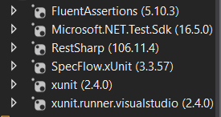

**Tests**

I have added BDD (SpecFlow) based tests to cover the API verification tests. I used both XUnit and FluentAssertion for asserting the tests and tests were passed after completing the steps.

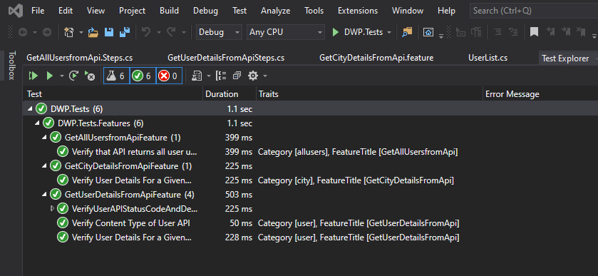

As an example the test feature “GetUserDetailsFromApi” covers status code, status description , content type , user name verifications of the API.

**Sample Feature file** GetUserDetailsFromApi

Feature: GetUserDetailsFromApi

*In order to verify user details*

*As an administrator*

*I want to get a specific user for a given user ID*

*@user*

Scenario Outline: Verify User API Status Code and Description

Given I send GET request to the API with valid user id <userid>

When I complete the request

Then I receive status code <statuscode> and status description <statusdescription>

Examples:

| *userid* | *statuscode* | *statusdescription* |

| "2" | 200 | "OK" |

| "xyz" | 404 | "NOT FOUND" |

*@user*

Scenario: Verify Content Type of User API

Given I send GET request to the API with valid user id "*2*"

When I complete the request

Then I receive "*application/json*" as content type

*@user*

Scenario: Verify User Details For a Given User Through User API

Given I send GET request to the API with valid user id "*2*"

When I complete the request

Then I read user first name as "*Bendix*" and last name as "*Halgarth*"

**Sample Step Definition**

using TechTalk.SpecFlow;

using RestSharp;

using Xunit;

using System.Net;

using Newtonsoft.Json;

using Newtonsoft.Json.Linq;

using Newtonsoft.Json.Serialization;

using DWP.Tests.Helper;

using FluentAssertions;

namespace DWP.Tests.Steps

{

[Binding]

public sealed class GetUserDetailsFromApiSteps

{

private RestClient client;

private RestRequest request;

private IRestResponse response;

[Given(@"I send GET request to the API with valid user id ""(.*)""")]

public void GivenISendGETRequestToTheAPIWithValidUserId(string userId)

{

string targetUrl = string.Concat("http://bpdts-test-app-v2.herokuapp.com/user/", userId);

client = new RestClient(targetUrl);

}

[When(@"I complete the request")]

public void WhenICompleteTheRequest()

{

request = new RestRequest(Method.GET);

}

[Then(@"I receive status code (.*) and status description ""(.*)""")]

public void ThenIReceiveStatusCodeAndStatusDescription(int expectedStatusCode, string expectedStatusDescription)

{

response = client.Execute(request);

Assert.Equal(expectedStatusCode, (int)response.StatusCode);

Assert.Equal(expectedStatusDescription, response.StatusDescription);

}

[Then(@"I receive ""(.*)"" as content type")]

public void ThenIReceiveAsContentType(string expectedContentType)

{

response = client.Execute(request);

Assert.Equal(expectedContentType, response.ContentType);

}

[Then(@"I read user first name as ""(.*)"" and last name as ""(.*)""")]

public void ThenIReadUserFirstNameAsAndLastNameAs(string expectedFirstName, string expectedLastName)

{

response = client.Execute(request);

if (response.IsSuccessful)

{

var user = JsonConvert.DeserializeObject<User>(response.Content);

user.FirstName.Should().Be(expectedFirstName);

user.LastName.Should().Be(expectedLastName);

}

}

}

}